Model for Improvement Worksheet

Topic Chosen for Improvement:

Once the topic is known, assemble a team representing each function that is involved in that topic (the people who do the work need to change the work.) This is the Quality improvement team, and together they answer the following three questions. Once the three questions are answered, the team implements rapid cycle improvements through the use of Plan Do Study Act (PDSA). See PDSA Worksheet.

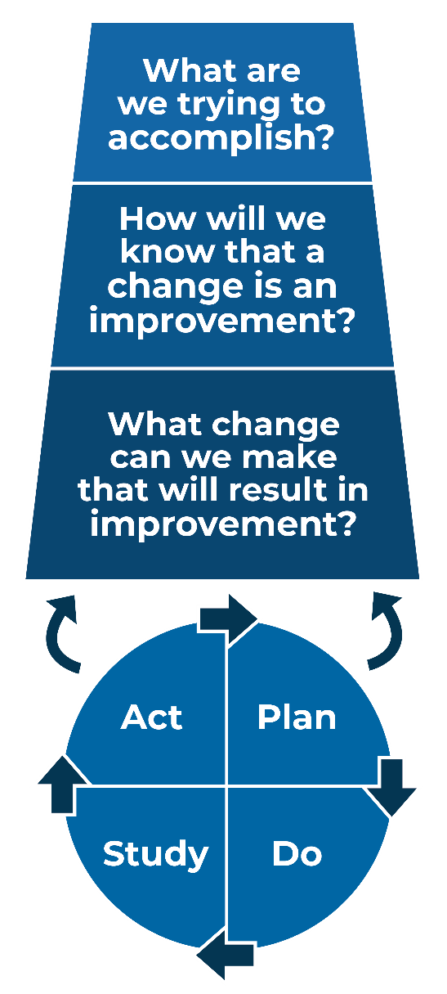
- The answer to this first question is the Aim Statement, is best worded as something of value to the patient and is specific and measurable so that there is a clear focus and pace. The NAME will improve TOPIC by ____%, from baseline to ____, by (date) ______________________.

- The answer to the second question defines how performance will be measured:

- The answer to the third question identifies the changes that will be made and draws on the change concepts or potentially better practices that improve quality.

To learn more, see our Practice Facilitator Core Training options.

