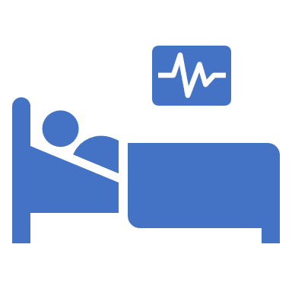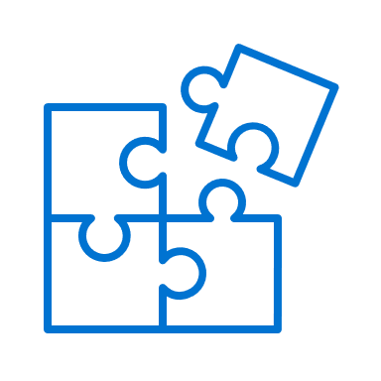****

Seeing the same family doctor and care team leads to better quality care than seeing a different doctor each time.

We are asking who you consider as your family doctor so we can provide the best care for you.

Identifying your family doctor helps put your health care pieces together so they can provide you with the best health care experience.

**My doctor and my health care team are here for me**



* We are asking you to share your family doctor’s name when receiving care at other clinics, specialists or the hospital.
* Identifying your family doctor does not remove your choice. You can change your family doctor.
* If you see more than one family doctor, pick a main one and let the other doctor know who your main doctor is.
* These simple steps help to connect your relevant health information to your family doctor. You will repeat your story less and they can plan for your future care needs.
* If you or a family member do not have a family doctor, call Health Link by dialing 811 or visit www.albertafindadoctor.org.

**I’m connected to the care I need!**

