Sequence to Achieve Change Workbook

Clinic Team: ___________________________
Change Package: ________________________

Elevator Speech
When you approach a team to consider quality improvement work, you’ll want to be prepared with an “elevator speech.” Use the tool below to help develop it.
Who You Are: | What You Do (short explanation):
Features: | Benefits:
Key Messages for Your “Elevator Speech”:

Anticipated Barriers: | Plan for Managing Barriers:

Form an Improvement Team
Next, assemble a team that represents all areas and roles of the clinic; consider including a patient on your team. Indicate below who is on your improvement team. It is recommended that you include someone with training in quality improvement facilitation (likely this will be you!) and someone with decision making authority (a physician champion or office manager).
Team Member Name | Role in Clinic

Clarify the Problem/Opportunity
Articulate the problem you want to solve. Use evidence and data to strengthen your rationale (consider reviewing the physician’s HQCA Primary Health Care Panel Report with them and the team). Discuss with your improvement team what aspects of the area you’re focusing on most need improvement. You may also want to use some QI tools like the Fishbone Diagram, 5 Why’s, or Pareto Chart.
Data that may support my change package:

When writing your problem or opportunity statement, consider the following questions:
Question | Answer
What is the problem?
Who does the problem affect?
When is it a problem?
Why should we care?
How does it affect patients?

Problem Statement:

Map Processes
Visually depict the sequence/steps of events in the process that you are trying to improve. Start by naming your process so that all team members are focusing on the same thing. Next, determine the start and ends points in the process. Use your team to brainstorm all of the steps that happen in between. Finally, arrange your steps in order.
Once you have your current state mapped, review it as a team. Consider the following questions:
Question | Answer
Where are the bottlenecks?
Where is work being duplicated?
Are their inconsistencies?
What can be standardized?
Does each step add value? If not, can it be eliminated?
Use the Process Mapping Guide in your Practice Facilitator Core Training as support.

Use the Model for Improvement
When making a change, the Institute for Healthcare Improvement Model for Improvement asks three questions:
- What are you trying to accomplish? – This is your aim statement.
- How will you know that a change is an improvement? – These are your measures.
- What change can be made that will result in an improvement? – These are your PBPs.
These three questions are followed by small tests of change called Plan-Do-Study-Act (PDSA) cycles.

Set an Aim Statement
Question | Answer
What are we trying to improve?

By how much? (Try a stretch goal!)
By when?
Aim Statement:

Identify Measures
Measurement is a key component of good quality improvement. Measurement allows you to track the changes that are occurring and assess their impact. There are three types of measures that can be collected:
- A process measure measures of whether an activity has been accomplished. Often used to determine if a PDSA cycle was carried out as planned.
- An outcome measure measures the performance of the system under study. Often relates directly to the aim of the project and offers evidence that changes are actually having an impact.
- A balancing measure determines the impact of a change on separate parts of the system.

QI Measure | Method of Collection | Frequency

EMR access varies by clinic and PCN so have a discussion with the team about which person or role is responsible for running the EMR report and what frequency makes the most sense for your circumstances.

Select Changes or Potentially Better Practices (PBPs) to Test
Use your change package table to select PBPs. Based on what you know about the impact they’d have and the effort they’d take, slot them into the PICK Chart below. Indicate which ones the team will try first: Impact/Effort Grid or PICK Chart
  - 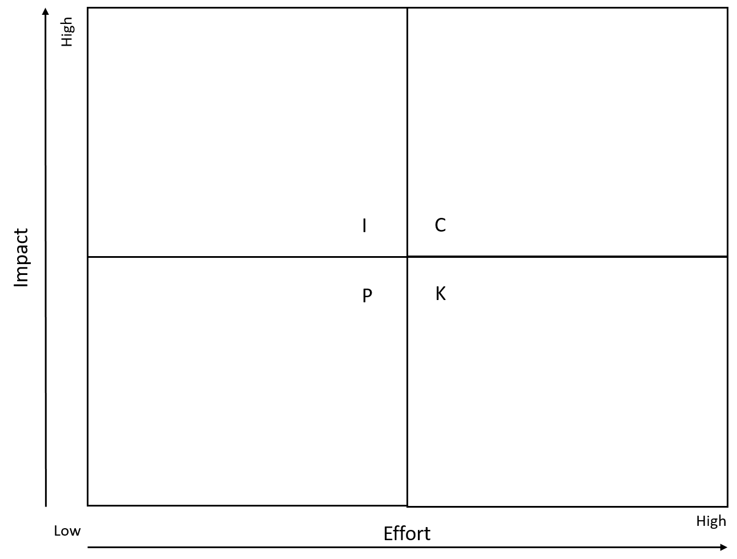

Test Changes
After a change idea is selected, use PDSA cycles to test changes in a real world setting. Consider starting with just one patient and one provider. Document each PDSA Cycle. Use the PDSA template in the QI Guide as support.

Sustain the Gains
Congratulations on making an improvement! However, now you’ve got to hold the gains. Some strategies to consider for maintaining improvements are:
- Standardization
- Accountability
- A visual management system
- Daily communication
Use the Five Strategies for Sustaining the Gains handout to learn more.
Additionally, measurement does not stop once you have improved your outcomes. Continue to periodically measure your results to ensure that improvements are sustained over time. Consider creating a quality improvement board and displaying results for both clinical staff and patients to see.

Spread the Successful Changes
After successful implementation with the initial site, the improvement team can work to spread learning and changes to other parts of the clinic or to other clinics within the Primary Care Network. While actual spread occurs at the end of a successful improvement initiative, improvement teams should develop strategies for spreading improvements from the beginning of the project.
Thinking of the work your currently doing with your team, how can it be spread (to other patient populations/to other physicians or clinics)?

Be aware of the Seven Spreadly Sins. Reference the Seven Spreadly Sins handout to learn more.

Celebrate!
Plan to celebrate at milestones along the improvement journey, as well as when you achieve your aim. Recognize and highlight the efforts and accomplishments of the team.
Brainstorm ways in which you might celebrate with a team:

