

**ASaP+ Measurement Guide**

**Table of Contents**

**Table of Contents** 2

**Introduction** 3

**Timing and Methodology** 4

**The Importance of Measurement** 4

**ASaP+ Measures Form** 4

Workbook Style 4

Demographics 5

**Measures** 5

Panel Size 5

Panel Confirmation Rate 5

Screening Rates 6

**Intervals of ASaP+ modifiable factor screening** 6

**Brief Intervention** 8

Eligible Patients for Brief Intervention 8

**Rationale** 8

**Eligible** 8

**Important EMR considerations** 8

Care Planning 11

**Sharing the Results** 13

Run Charts 13

**Appendix A: ASaP+ Measures Definitions** 14

**Appendix B: ASaP+ Maneuvers Menu** 15

**Appendix C: ASaP+ EMR Resources** 16

**Introduction**

The Alberta Screening and Prevention Plus (ASaP+) measures, as described in this document, are selected to inform quality improvement work across all participating Primary Care Networks (PCN). These measures are anticipated to help clinic teams improve their confidence and capability to support patients with ASaP+ modifiable factors. Clinic teams are encouraged to use these measures as a learning tool (e.g., for PDSAs [Plan/Do/Study/Act]). While the actual values of the measures may be useful to clinic teams, the process of capturing these measures will also build skills and capacity within teams to measure for quality improvement.

These measures are not collected for the purpose of submission and will not be used for comparison purposes across clinics, rather the activities will leverage and build on existing ASaP work and enhance screening work. The data collected is an excellent opportunity for learning, reflective work and developing improvement.

The ASaP+ measures consist of four quantitative measures that will be obtained from the Electronic Medical Record (EMR). These measures are designed and calculated using the panel for each provider. Practices are encouraged to reflect on process (short term) and outcome (long term) measures to monitor progress toward goals and consistency of process implementation.

The feedback on the collection and use of these measures is intended to inform improvement over time. For some of these measures, PCNs and clinics may have existing processes for collection of screening data. The creation of new processes may be needed but when possible, developing systematic workflows layered onto existing processes is encouraged. Where existing processes do not exist, this document provides some strategies and suggested methodologies to help clinics get started.

**Timing and Methodology**

All measures can be collected at an appropriate pace set by the clinic. Use the *Sample Quality Improvement Plan for ASaP+* which can be found on the ACTT website as a guide in developing a tailored practice improvement plan. A measures form is provided in the ASaP+ materials and can be used to record and share data with the clinic team implementing ASaP+. Clinics may wish to track these measures more frequently (1-3 months) as part of their QI work, to discuss and identify any implementation barriers/challenges.

**The Importance of Measurement**

Leveraging the EMR as a clinical support tool led to an increase of cancer detected at early stages. The proactive and panel-based approach resulted in significant reductions in patient treatment and projected health system costs. As tobacco use, alcohol use, physical inactivity, and low vegetable and fruit intake are the largest contributors to chronic disease and cancers, the work has been elevated, resulting in the development of ASaP+.

Measurement is an important exercise that allows the medical home team to understand the impact of ASaP+ on the practice, physicians and patients. The purpose of measurement is not to make judgements, but rather to learn how this piece of work is adapted into a primary care setting. By reflecting on measurement, the team will be able to manage the evolution of this work by predicting challenges, mitigating risks, and developing additional supports if required. This kind of reflection can support the success of the work and ultimately, improve the capability of primary care to offer proactive screening of modifiable factors and support patients in making positive health changes.

**ASaP+ Measures Form**

The measures form can be completed for each provider participating in ASaP+. For quality improvement purposes, data can be collected at regular intervals that can be determined by the Medical Home team. Some notes for data entry:

* If the clinic is not currently documenting a screening maneuver, leave the cell blank.
* No fields are mandatory.
* The ACTT website has EMR guides and resources (e.g., videos) for each of the five predominant EMRs across the province, including screenshots and suggested methods for capturing data (Appendix C).
* Contact your EMR vendor for additional support if appropriate.
* Sharing of the data as a discussion point and to review the data as a team is encouraged to develop strong internal communications.

Workbook Style

The measures form is created as an Excel workbook with several tabs.

C:\Users\muhammadmughal\Desktop\ASaP+\ASaP+ Evaluation Report\Tab.jpg

The first tab includes instructions for completion. The tabs entitled, “Baseline Measures”, “6-month Measures”, and “12-month Measures” are used to collect quantitative measure information.

Demographics

The first section of each “Collection” tab is entitled, “Part 1: Demographics”. This section can be completed at the beginning of implementation using the “Baseline Measures” tab. Once it is completed, subsequent tabs will auto-fill with the same information.



**Measures**

The measures form excel document is a tool to help capture screening rates and other calculations collected from the EMR. A brief explanation of these various measures follows. EMR resources to support building searches are supplied in Appendix C.

Panel Size

Collection of measures from the EMR is a method by which the practice can gauge the success of implementing new processes. The first step in determining how to measure anything in a panel is establishing the size of the panel (how many patients are attached to a provider). Then segmenting the portion of the panel over 18 years of age will become the denominator of all calculations (number of patients eligible for the screen).



Panel Confirmation Rate

The panel confirmation rate is a percentage:

* Numerator: Number of patients with attachment confirmed within the previous ‘x’ years.
* Denominator: Number of patients presenting to the provider within the previous ‘x’ years.

For example, the calculation might look like this:

# patients in the panel seen and confirmed in the last 3 years x 100 = confirmed rate (%)

# patients in the panel seen in the last 3 years

To determine the panel, a clinic may use any of the following:

* A three-year look back (most recommended).
* A four-year look back.
* A five-year look back.
* The confirmed panel only.



Quality Improvement tip: Calculating clinic or provider confirmation rates frequently (e.g., monthly) is a process measure that can be done to monitor whether panel validation processes in the clinic are improving or maintained

The numerator and denominator are entered into the data form on line 15. Once the data is entered, the percentage will be auto-calculated. The definition used to calculate the panel confirmation rate can then be selected from the drop down list on line 16.



Screening Rates

Each screening maneuver that the practice is reporting is calculated using the number of eligible patients who have that screening maneuver documented in the EMR over all those eligible. Some of the screening maneuvers may be new to the clinic and may not have been documented prior to starting ASaP+.

**Intervals of ASaP+ modifiable factor screening**

The interval for screening each modifiable factor is annually. If the provider was not documenting the screening maneuvers prior to starting ASaP+, they should be searched for in the EMR since the ASaP+ implementation date. If the provider was documenting the screening maneuver prior to the implementation of ASaP+, the EMR search can be created using the “last 12 months” in the search criteria.

Screening rates for ASaP are collected in addition to rates collected for ASaP+. As ASaP+ is an enhancement to ASaP work, these measures will help the practice not only monitor increasing rates for ASaP+ but also inform whether previous ASaP processes are being maintained while ASaP+ is being implemented. Ongoing measurement will also allow practices to monitor and reflect on adoption of ASaP+ screening processes.

The practice may already be reporting screening rates from their EMR and sharing with the team and/or reporting externally to their PCN for Schedule B. Any rates currently being produced should continue to be produced to support ongoing work. Screening rates should be produced in alignment with the established ASaP screening intervals and eligibility.

If a practice is producing screening rates for tobacco, exercise/physical activity and alcohol, they can continue to do so using ASaP methodology.

**Numerator:** Number of eligible patients with documented completed screens. Documented offers of screening can also be included in the numerator if the practice is recording offers of care.

**Denominator:** For the purposes of ASaP+, the denominator for tobacco, exercise/physical activity, alcohol, and vegetables and fruits is all patients in the panel over the age of 18. (Can also be expressed as all patients in the panel eligible for the screen).

The calculation for each modifiable factor may look like this:

# patients age 18+ in the panel seen in the last year, with a verified

tobacco, exercise/physical activity, alcohol, or vegetables and fruits   
status documented in the last year or since ASaP+ implementation x 100 = confirmed rate (%)

# patients age 18+ in the panel seen in the last year or since ASaP+   
implementation

The numerator and denominator for each maneuver are entered into the data form beginning on line 20. Once the data is entered, the percentage will be auto-calculated.

Please note: denominator cells in blue will be auto-populated from a previous lines’ value.

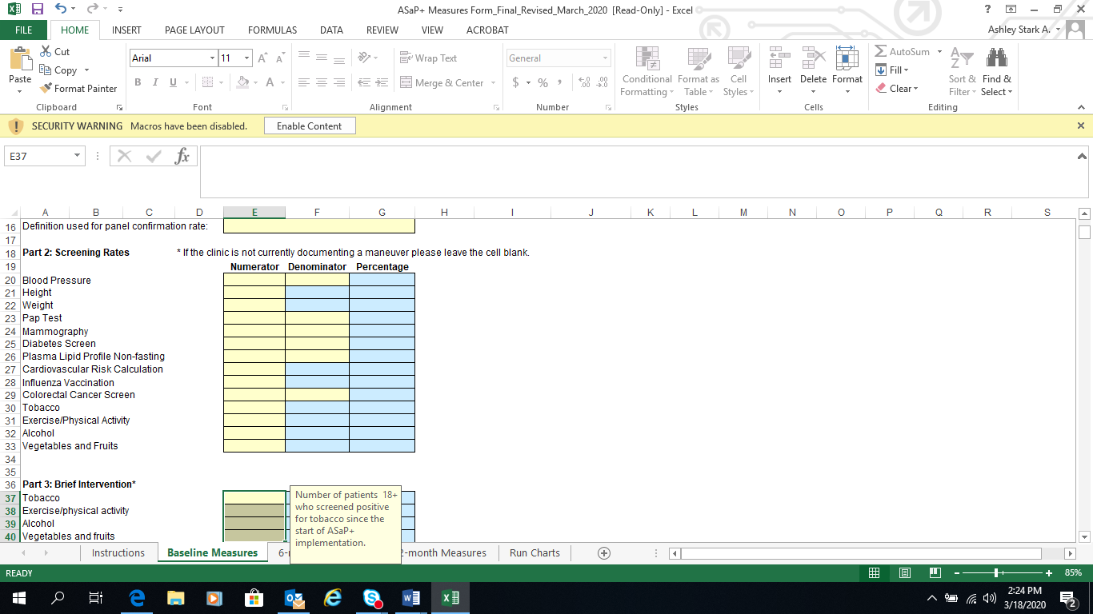

**Brief Intervention**

Eligible Patients for Brief Intervention

For each ASaP+ screening maneuver, patients who screened positive for a modifiable factor in the last year, or since ASaP+ implementation, are eligible for brief intervention. A positive screen is defined as any patient for whom brief intervention will be appropriate (i.e. referrals, care planning and prescription).

**Rationale**

To understand the impact that practices are making by offering brief intervention to the appropriate patients, this measure distills the screened population to those who screened positive. In ASaP+ the screening process is tied to an offer of brief intervention when appropriate, so this measure will be a proxy of offers of care. These searches will support the clinic to determine which patients may require follow-up care and create awareness of patients who would not have been identified without the work of ASaP+. As the ASaP+ measures are likely to be new for most clinics, it is recommended to collect these measures at 6 and 12-months.

**Eligible**

Patients who screened positive for an ASaP+ maneuver (tobacco, exercise/physical activity, alcohol, vegetable and fruits). The calculations for patients eligible for brief intervention will look like this:

# patients in the panel age 18+, with a verified Tobacco status and who are users of tobacco products)

In the last year or since ASaP+ implementation _________________________ x 100 = confirmed rate (%)

# patients age 18+ in the panel *with a verified Tobacco status in the last one year*

# patients in the panel age 18+, with a verified Exercise/Physical Activity status and who exercise/ are physically active less than guidelines)

In the last year or since ASaP+ implementation _________________________ x 100 = confirmed rate (%)

# patients in the panel age 18+ with a verified Exercise/ Physical Activity status in the last one year

# patients in the panel age 18+, with a verified Alcohol status and drink in excess of guidelines)

In the last year or since ASaP+ implementation _________________________ x 100 = confirmed rate (%)

# patients age 18+ in the panel *with a verified Alcohol status in the last one year*

# patients in the panel age 18+, with a verified Vegetables and Fruits status and consume less than guidelines)

In the last year or since ASaP+ implementation _________________________ x 100 = confirmed rate (%)

# patients in the panel age 18+ with a verified Vegetables and Fruits status in the last one year

**Important EMR considerations**

Practices will likely need to configure options the team will use to document modifiable factors that will help identify patients who screen positive for increased risk. This will be EMR-specific and will rely on the EMR knowledge of the team. If the team does not possess advanced EMR knowledge, call your EMR vendor or a peer super-user to learn how to do this in your EMR. In order to search how many patients are eligible for brief intervention, the search functions need to look for all the potential responses for each screen. For example, when screening for exercise/physical activity, the EMR may have various responses such as ‘sedentary’, 30 mins per week, 60 mins per week, 120 mins per week, etc. Each maneuver needs a standardized list that enables good reporting. Before changing anything consider the following:

* Assess your EMR to see if there are configured options to choose from. Understand what already exists in the EMR.
* Discuss as a team how information is entered into the EMR (for each maneuver) by using the EMR data entry assessment tool in the ASaP+ materials. It will become apparent whether you can create a search that looks for data in one field, or is data in various fields already. If there is variation in the data entry, the next step is to see where the team can align and ensure data entry into one place. If this is not possible, searches will need to be created for each provider, dependent on where data is being captured. When possible, build on what already exists rather than creating a new workflow.
* Determine what selection is a positive versus negative screen. For example, ‘sedentary’ may be considered a positive screen, meaning this patient may be eligible for brief intervention/ ‘150mins per week’ may be considered a negative screen, meaning the patient has good exercise/physical activity habits and therefore doesn’t need brief intervention. This will be essential to your reporting later on. To search for patients who are eligible for brief intervention, the search needs to find every patient who is ‘sedentary’.

The following are possible options that can be configured into a clinic’s EMR. Most EMRs do not have a list and must be configured. These options help indicate what to include in the numerator of positive screens.

* Tobacco
  + Current Tobacco User (Positive)
  + Ex-Tobacco User (Negative)
  + Never a Tobacco User (Negative)
  + Defer
  + Exclude
* Exercise/Physical Activity
  + Meets Recommendations (Negative)
  + Below Recommendations (Positive)
  + Sedentary (Positive)
  + Defer (offered but declined by patient)
  + Exclude (Not applicable for this screen [i.e., Quadriplegic])
* Alcohol
  + Non-drinker (Negative)
  + Past Drinker, in recovery (Positive)
  + Drinker – not at risk (Negative)
  + Drinker – elevated risk (Positive)
  + Defer
  + Exclude
* Vegetables and Fruits
  + Meets recommended intake (Negative)
  + Low intake – at risk (Positive)
  + None – at risk (Positive)
  + Defer
  + Exclude



Pro tips:

* Recording ‘defer’ can be an option for recording offers of care.
* Recording ‘exclude’ option can be helpful in removing these patients from your eligible denominator.
* Leave ‘defer’ and ‘exclude’ out altogether to keep the options simple.

The above examples of configured options are suggestions only. If the providers have already created existing options, determine which ones are negative and positive and build the EMR search from there

The numerator for each measure is entered into the data form in lines 37-40. Once the data is entered, the percentage will be auto-calculated.

Please note: the denominators cells in blue will be auto-populated.



Care Planning

Care Planning is an important measure to monitor patients who have screened positive for a modifiable factor. The presence of a care planning template or care planning in the chart demonstrates that not only has the practice identified those patients with a positive modifiable factor, but can also demonstrate that brief intervention has been provided. For example, if a patient screens positive for tobacco use, the presence of a care plan template can demonstrate:

* use of the extended medical home team or health neighborhood (was the patient supported by a CDM nurse or referred to community/provincial resources?);
* if the patient has been provided with materials, resources, a prescription, and/or advice on how to make positive health changes;
* if the team helped the patient co-develop their care plan.

The simplest method to capture care planning is by using the Care Plan Template found in the ASaP+ materials on the ACTT website. This document can be co-developed by the team and patient, then saved or scanned to the EMR. On the measures form, for each ASaP+ maneuver, the team can reflect on whether patients eligible for a brief intervention indeed received some kind of intervention or had a care plan completed.



Quality Improvement tips: If the team is interested in knowing how to best use the PCN resources that are available, here are suggested ways to support patients eligible for brief intervention:

* First reflect on how many patients are eligible for brief intervention for each modifiable factor. Is it apparent there is a high number of tobacco users in the practice?
* Consider holding classes or referring each patient to a PCN/community tobacco cessation class.
* Have the highest risk patients received a care plan? Discuss as a team and prioritize care with the help of the provider.

Below is an example of potential care plan measures from the EMR. The numerators for each measure are entered into the data form in lines 44-47. Once the data is entered, the percentage will be auto-calculated.

Discuss as a team what measures would be most meaningful. Focus on one maneuver or brainstorm ideas of other care plan measures to support practice goals.

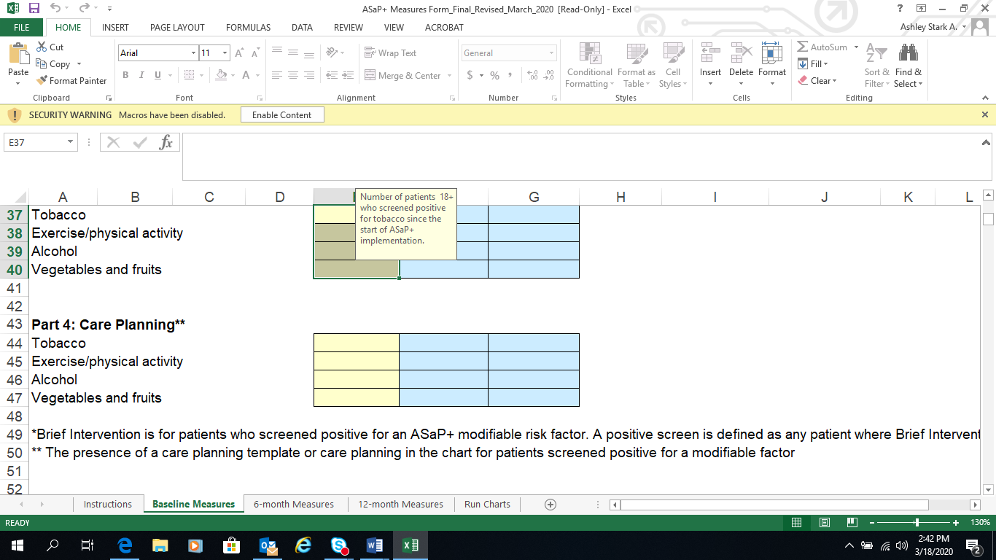

**Sharing the Results**

Run Charts

Once the data has been entered into the measures form, the run charts located in the final tab ‘Run Charts’ will auto-populate with your own data. Over time, these will be automated run charts of your own data.

Charts show the proportion of patients:

* Screened for Tobacco
* Screened for Exercise/Physical Activity
* Screened for Alcohol
* Screened for Vegetables and Fruits

Example:

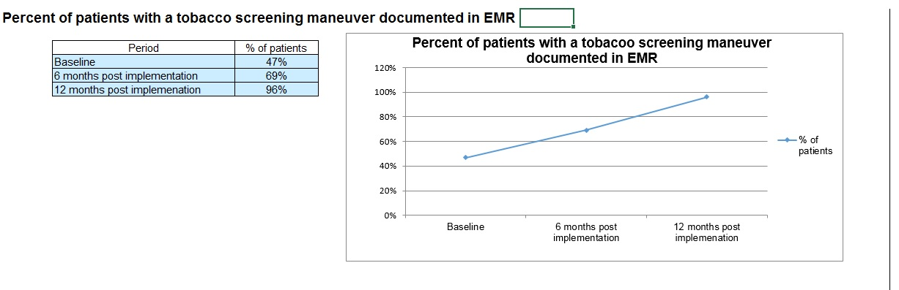**Screening Rates** – The team can determine how often they will collect and reflect on screening rates. Suggested time points might be at baseline, 6 months and 12 months. At each specified data collection time point, the results can be shared with the team. Print out the run charts provided in the measures form for a helpful visual representation.

**Care Planning** – Increasing the frequency of care planning is an important aspect of brief intervention. The practice can monitor for care plans completed and updated within the past year in the EMR for patients who screened positive for an ASaP+ maneuver.



Pro tip:

Create as many run charts as desired by the team. Pick 3 measures to follow and make sure to build on them by updating the charts prior to team meetings. Discuss and celebrate successes!

**Appendix A: ASaP+ Measures Definitions**

EMR-based quantitative measures

**Eligible Patients for Brief Intervention:** For each ASaP+ screening maneuver, the percentage of patients who screened positive of the patients screened in the last year or since ASaP+ implementation. A positive screen is defined as any patient where Brief Intervention, (i.e. referrals, care planning, prescription etc.) is appropriate.

**Panel:** A group of patients for whom a primary provider(s) and team is responsible for providing comprehensive and longitudinal care. There is a confirmed relationship between the primary provider and the patient.

**Panel Confirmation Rate:** A calculation that is an important process check that reflects how often a team is confirming the identity of the patient’s primary provider. A percentage of patients presenting to the provider who have confirmed their attachment to that provider.

Confirmation rate = # of patients confirmed in a time period   
 # of patient visits in the same time period × 100%

**Screening Rates:** For each screening maneuver the practice is reporting, the percentage of eligible patients who have that screening maneuver documented in the EMR over all those eligible for the screen.

Additional definitions

**ASaP+ modifiable factors:** Tobacco, Exercise/Physical Activity, Alcohol, Vegetables and Fruits

**Attachment:** An attachment is the expression of a continuous longitudinal relationship between individuals (“patients”) and their primary provider. Continuous relationships over time support continuity of care.

**Confirmed attachment:** The process of documenting and date stamping attachment within the EMR.

**Eligible (for screening):** Appropriate screening is defined according to the screening maneuvers menu, which specifies the age, gender, and frequency of screening (see Appendix B).

**Implementation date:** The date upon which the clinic decides to implement the ASaP+ maneuvers.

**Primary provider:** The provider(s) most responsible for providing comprehensive primary care longitudinally over time to a panel of patients. May be a physician or nurse practitioner.

**Appendix B: Revised ASaP+ Maneuvers Menu for Adults 2018**

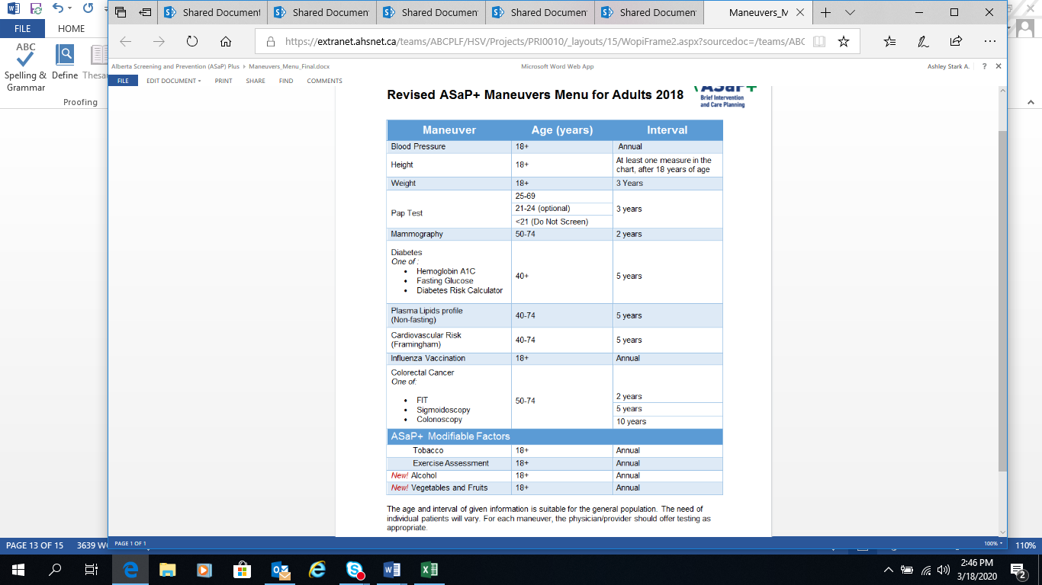

**Appendix C: ASaP+ EMR Resources**

The Accelerating Change Transformation Team (ACTT) website has a number of EMR and Practice Facilitator resources that can support ASaP+ work.

**EMR Guides**

[Med Access Tip sheet, ASaP+ section (page 55)](https://top.albertadoctors.org/file/med-access-emr-guide-for-pmh.pdf)

[Accuro Tip sheet, ASaP+ section (page 47)](https://top.albertadoctors.org/file/accuro-emr-guide-for-pmh.pdf)

[Wolf Tip sheet, ASaP+ section (page 63)](https://top.albertadoctors.org/file/wolf-emr-guide-2018-1.pdf)

[Healthquest Tip sheet, ASaP+ section (page 62)](https://top.albertadoctors.org/file/healthquest-emr-guide-for-pmh-2018-03.pdf)

[PS Suite Tip sheet](https://top.albertadoctors.org/file/using-practice-solutions-suite-to-support-patient’s-medical-home.pdf) ASaP+ section to be added in December

To find more EMR resources including short videos that support EMR optimization, [click here](https://top.albertadoctors.org/EMR/Pages/default.aspx).

**EMR Network – Alberta**

ACTT have partnered with PCN and clinic EMR experts to deliver a provincial EMR Network. The objectives of the network are to:

* Build connections between EMR users across the province.
* Develop knowledge, skills, and abilities that support QI in the EMR within the Patient’s Medical Home (PMH).
* Provide a venue to share leading practices, tools, resources, and innovations/solutions to EMR challenges.

Connect with other EMR users across Alberta to support ASaP+ in practice. [Sign up for the EMR Network](https://www.regonline.ca/emrprovincialnetwork-sign-up) – Alberta.

**The Practice Facilitator Network – Alberta**

The Practice Facilitator Network is a platform for Practice Facilitators to connect and allow shared learning, collaboration and rapid spread of promising ideas. Current work in Alberta is discussed through a quality improvement lens, supporting those who are adopting provincial work and advancing the Patient’s Medical Home. For more information, [click here.](https://top.albertadoctors.org/PMH/capacity-for-improvement/practicefacilitationresources/Pages/default.aspx)